Project Limekist Website

Ethan Machado

February 7th, 2022

About: Project Limekist is a website featuring a 1971 Pontiac Firebird Formula 350 that I made. It details and documents the project that my father and I have worked on for the past eight years. I constructed this website using HTML and CSS from scratch. I have this website published online using GitHub pages at the URL: <https://ethanmachado.github.io/>

Here are screenshots of the website:

Home:

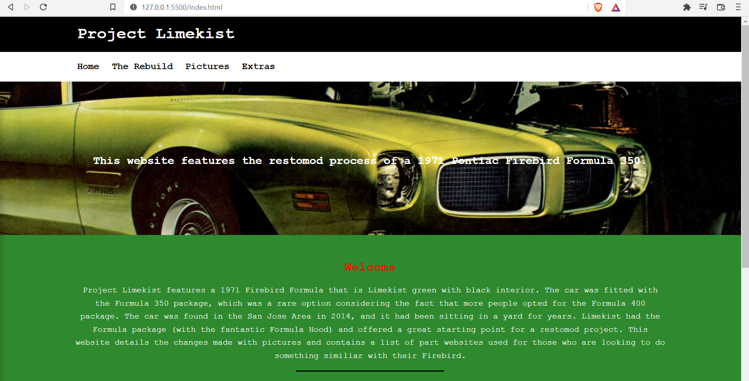

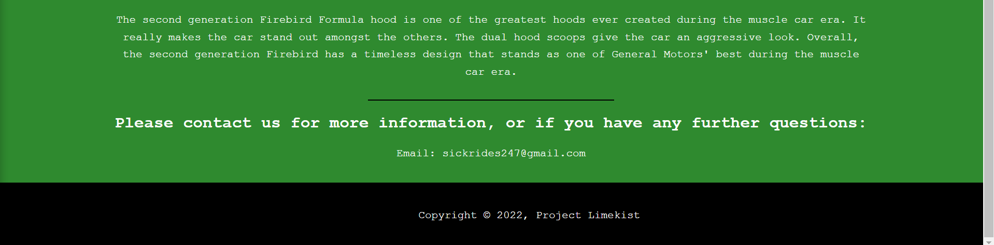

The Rebuild: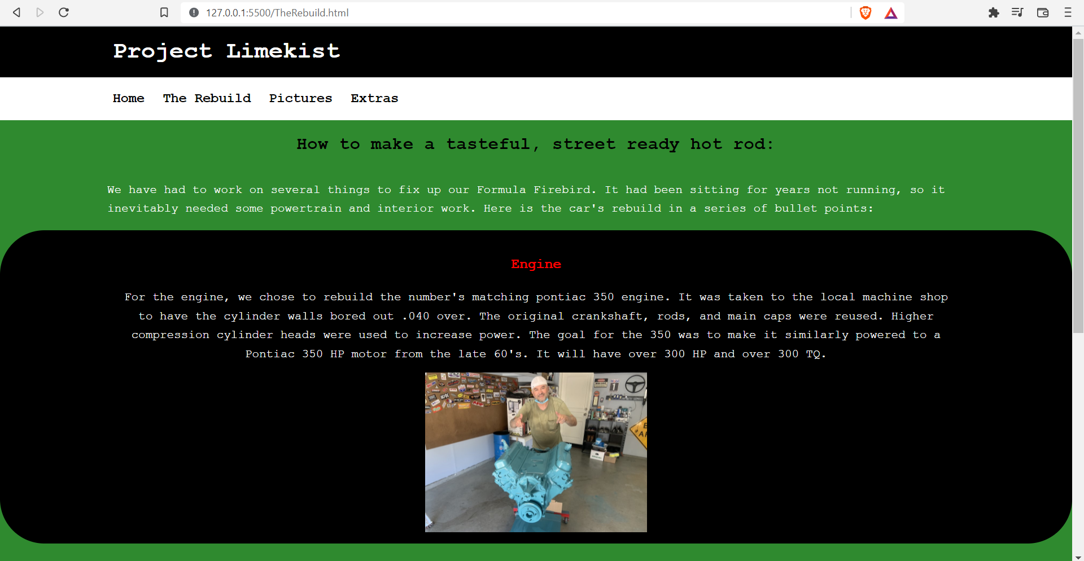

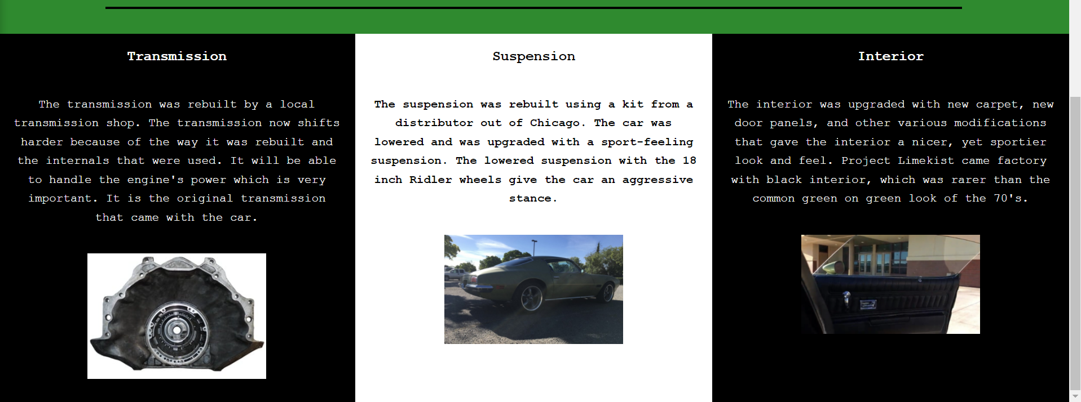

Pictures:

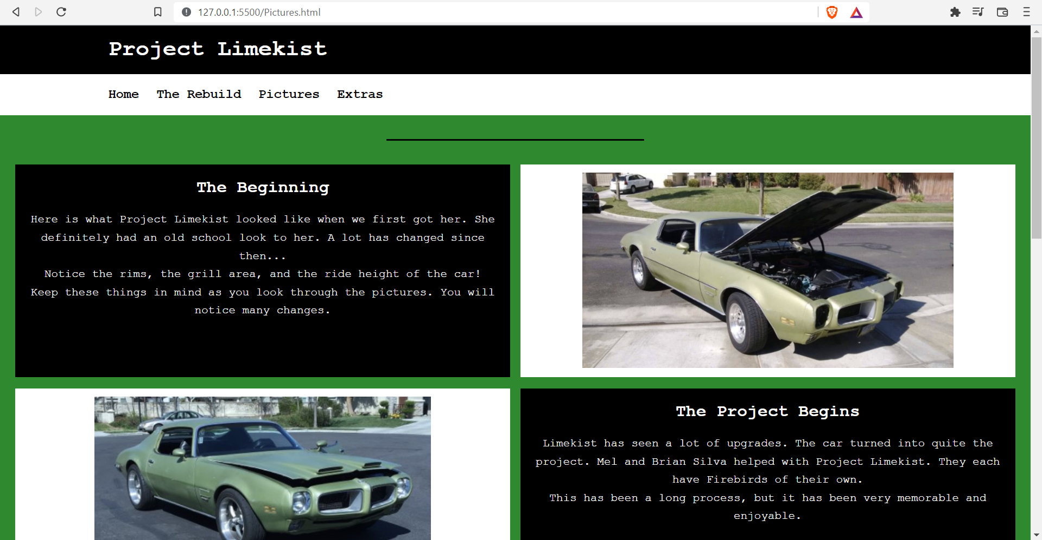

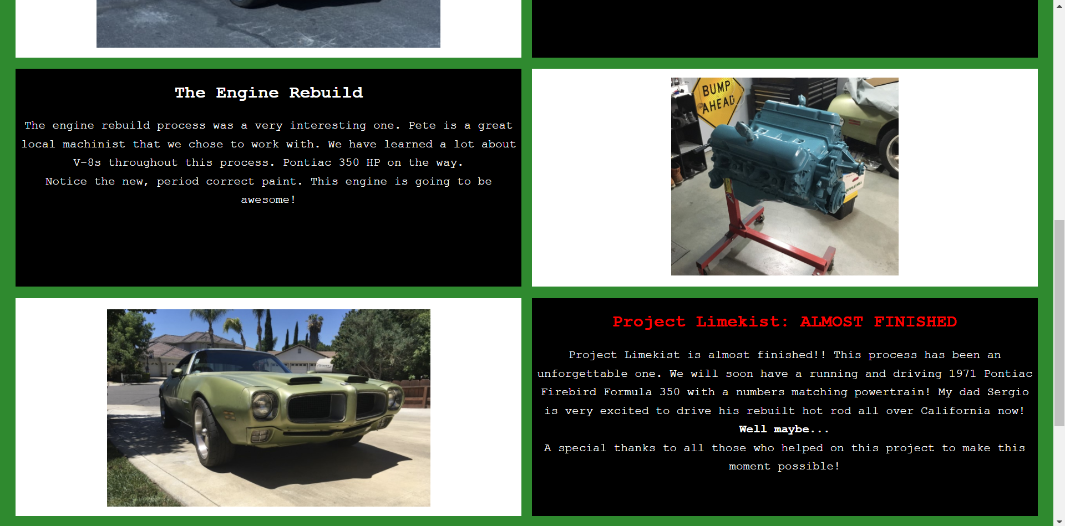

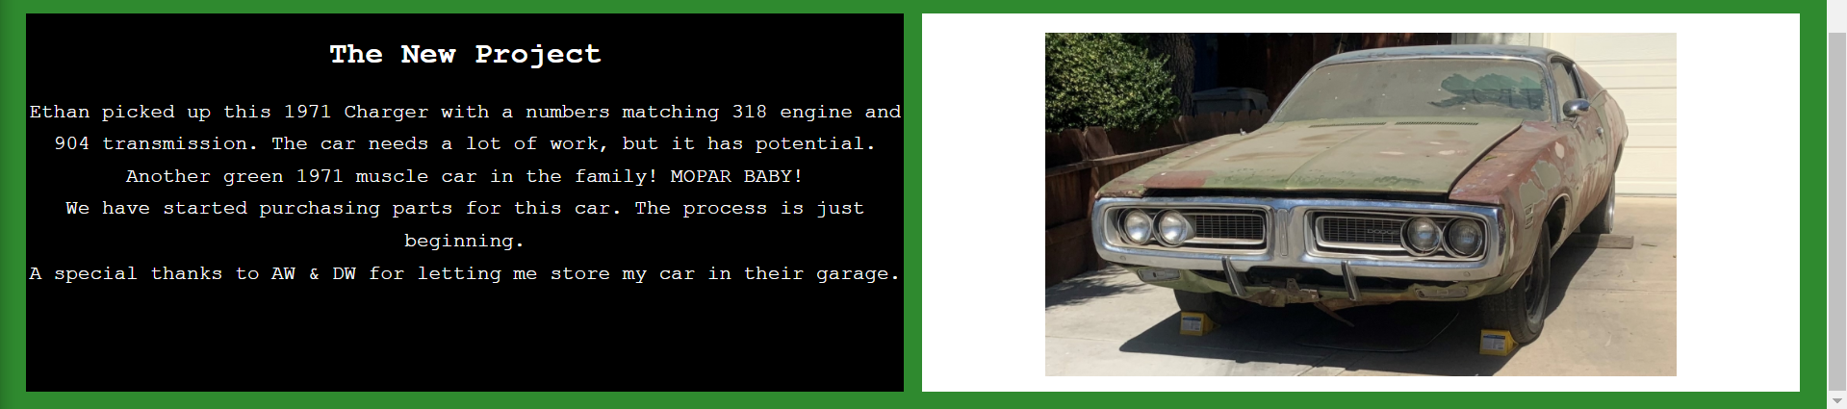

Extras:

